|  |  |
| --- | --- |
| \\VFILERDPI\DPI-Home\OBRIENR2\My Documents\Downloads\PP logo.jpg |  |
| **COUNCIL ASSESSMENT REPORT**  HUNTER AND CENTRAL COAST REGIONAL PLANNING PANEL | |

|  |  |
| --- | --- |
| PANEL REFERENCE & DA NUMBER | PPSHCC-103  DA/2899/2021 |
| PROPOSAL | Seniors housing (independent living units) and commercial premises |
| ADDRESS | 72 Wilsons Road, Mount Hutton  Lot 13 DP 11260 |
| APPLICANT | WPP Pty Ltd |
| OWNER | Lena Nicholson |
| DA LODGEMENT DATE | 8 November 2021 |
| APPLICATION TYPE | General development with a capital investment value over $30 million |
| CIV | $33,755,143 (excluding GST) |
| CLAUSE 4.6 REQUESTS | Clause 4.3 Height of buildings |
| LIST OF ALL RELEVANT PLANNING CONTROLS (S4.15(1)(A) OF EP&A ACT) | *State Environmental Planning Policy (Building Sustainability Index: BASIX) 2004*  *State Environmental Planning Policy (Biodiversity and Conservation) 2021*  *State Environmental Planning Policy (Resilience and Hazards) 2021*  *State Environmental Planning Policy (Housing for Seniors or People with a Disability) 2004*  *State Environmental Planning Policy (Housing) 2021*  *State Environmental Planning Policy (Transport and Infrastructure) 2021*  *State Environmental Planning Policy (Planning Systems) 2021*  *State Environmental Planning Policy (SEPP) No. 65 – Design Quality of Residential Apartment Building*  *Lake Macquarie Local Environmental Plan 2014*  *Lake Macquarie Development Control Plan 2014* |
| TOTAL & UNIQUE SUBMISSIONS | Nil |
| DOCUMENTS SUBMITTED FOR CONSIDERATION | **Plans**   * Architectural plans (April 2022) * Landscape plans (April 2022) * Amended lower floor sedimentation and erosion control plan (August 2021) * Bulk earthworks plan (April 2022) * Sediment and erosion control plan (February 2022) * Strategic concept right hand turn lane design (March 2022)   **Reports and documentation**   * Acoustic assessment addendum (January 2022) * Acoustic Assessment (September 2021) * Disability Access report (October 2021) * Arboricultural assessment report (October 2021) * Tree protection plan (October 2021) * Geotechnical investigation report (October 2021) * Detailed Site Investigation (October 2021) * CPTED report (July 2021) * Traffic impact assessment (October 2021) * Civil, stormwater and flood assessment (October 2021) * Social impact assessment (February 2022)   **Attachments**   * Attachment A: Draft conditions of consent * Attachment B: ADG compliance table * Attachment C: SEPP (Housing) 2021 compliance table |
| SPECIAL INFRASTRUCTURE CONTRIBUTIONS (S7.24) | N/A |
| RECOMMENDATION | Approval |
| DRAFT CONDITIONS TO APPLICANT | Yes |
| SCHEDULED MEETING DATE | 11 May 2022 |
| PREPARED BY | Leena Sebastian, Senior Development Planner |
| DATE OF REPORT | 4 May 2022 |

**EXECUTIVE SUMMARY**

Consent is sought for seniors housing and commercial premises at 72 Wilsons Road, Mount Hutton. The development will provide 72 independent living units in the form of residential flat development with commercial spaces at the frontage. The proposal relies on the provisions of *Lake Macquarie Local Environmental Plan* 2014 for permissibility.

The application is referred to the Hunter and Central Coast Regional Planning Panel for determination as it falls within the category of general development with capital investment value exceeding $30 million.

The application was exhibited from 11 November to 2 December 2021 and no submissions were received.

A kick-off briefing was held with the Hunter and Central Coast Regional Planning Panel on 8 December 2021, followed by a briefing on 3 March 2022. All matters raised in these meetings and additional information requested by Council have been adequately addressed by the applicant.

The application was referred to Natural Resource Access Regulator and Water NSW for integrated development approval under the *Water Management Act 2000,* and General Terms of Approval have been obtained.

Advice was sought from Ausgrid for works in the vicinity of overhead powerlines and no objections were raised.

The design was reviewed and highly commended by Council’s SEPP 65 Design Review Panel, with minor recommendations provided, which have been adequately addressed in the amended design.

The development was referred to local NSW police in accordance with Council’s practice, and no response has been received during the assessment process.

The proposal is consistent with the zone objectives, and aligns with the strategic intent and built form outcomes in Mount Hutton Town Centre Plan.

Minor parts of the development exceed the height control in the Lake Macquarie Local Environmental Plan by a maximum of 9.96%. The exceedance is supported by a clause 4.6 variation request to justify this variation.

The application is accompanied by a suite of specialist report studies to identify potential impacts. Appropriate design outcomes and mitigation measures have been included to enable the development to co-exist with other surrounding uses without adverse impacts.

Site remediation and validation will be required to render the site suitable for the proposed use. The proposal includes suitable landscape treatment and fencing at the interface to an adjoining tavern for visual privacy, amenity and safety. The development is capable of complying with relevant noise criteria with treatment to the glazing of windows included to eliminate low frequency entertainment noise. Suitable measures have been included to ensure the safety and security of the premises.

The proposal reflects a high quality urban from that is well responsive to the site’s constraints while providing suitable activation to Wilsons Road and recreational reserve at the rear.

In assessing the development against all relevant statutory and non-statutory planning instruments and policies, it is considered to have merits for approval, subject to conditions of consent contained in Attachment A.

1. **THE SITE AND LOCALITY**

The site is a split zoned parcel with an area of 1.6ha, located between Wilsons Road and Scrubby Creek. The majority of the site is zoned B2 Local Centre with a small stretch of RE1 Public Recreation land along the riparian area, as shown in Figure 1. The RE1 zoned part of the site is identified for acquisition for the purpose of local open space.

A single storey dwelling and ancillary sheds are located on the site. Vegetation on the site is largely confined to the south-west corner fronting Wilsons Road and the creek line to the rear.

The site generally falls from the road towards Scrubby Creek, with a change in level of approximately 7m between highest point at the road frontage and the lowest point in the north-east corner.

Surrounding uses are predominantly low-density residential developments. To the east of the site is a similar undeveloped parcel of land containing a single dwelling. A tavern is located to the immediate west of the site, beyond which lies the local shopping centre.

The locality depicts a transition in built form, particularly in the vicinity of the commercial precinct. Some of the larger lots near the shopping centre have been developed into townhouses and aged care facilities. Two other aged care facilities are located within 500m to the west and south-west of the site.

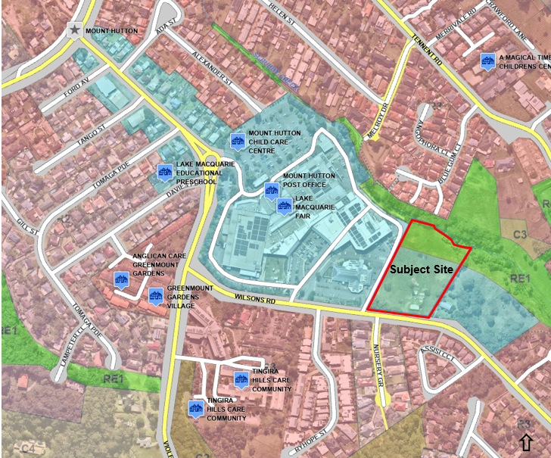

**Figure 1: Location map with zoning overlay**

1. **THE PROPOSAL AND BACKGROUND** 
   1. **The proposal**

The proposal is for a mixed-use development comprising seniors housing and commercial premises. Specifically, the development involves:

* two residential flat buildings, each three-storeys, containing 72 independent living dwellings for seniors in the following mix:
* 46 x 2-bedroom dwellings
* 26 x 2-bedroom plus study dwellings
* basement level containing 83 parking spaces and communal spaces for the residents
* 300m2 of commercial space with associated parking spaces at street level, and additional communal spaces for seniors
* vehicle access off Wilsons Road with separate entries to the commercial and residential uses.

The design concept is based upon a central recreational spine, with residential flat buildings on either side. Commercial spaces are provided along the frontage of the building for street activation. While the commercial and residential spaces are designed to function independently, these structures are integrated externally to create a unified built form on the site.

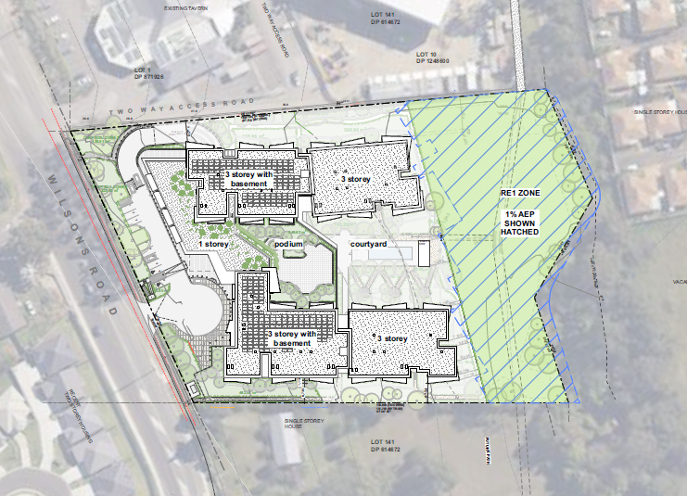

**Figure 2: Site plan**

Other works proposed include:

* demolition of all existing structures
* removal of 31 trees from the B2 zoned part of the site
* erection of fencing along site boundaries and RE1 interface
* internal pathways linking to the recreational reserve
* landscaping along the frontage, side boundaries and within the central communal area
* shared pathway on the RE1 land connecting to the adjoining shopping centre
* construction of drainage pipe across RE1 land for conveying stormwater overflow to the creek
* adjustment to the right turning lane on Wilsons Road to provide access to the site.

The development will be owned and operated by the Oak Tree Group. A site manager will be employed to oversee the general welfare of the residents and other day to day operations such as waste management and general maintenance activities.

The key development data is provided in Table 1.

**Table 1: Key development data**

|  |  |
| --- | --- |
| **Control** | **Proposal** |
| Site area (including RE1 zone) | 15,665m2 |
| Site area (excluding RE1 zone) | 11,320m2 |
| Site coverage (B2 zone) | Approximately 50% |
| Clause 4.6 Request | Height variation up to a maximum of 1.295m to accommodate roof elements and lift overrun of the front buildings. |
| Max height | 14.295m |
| Landscaped area (excluding RE1 zone) | 2,959m2 |
| Car parking spaces | Seniors housing: 85 spaces at basement level + 2 streel level parking for visitors  Commercial use: 8 spaces |

* 1. **Background**

A pre-lodgement meeting was held before the lodgement of the application in 23 June 2021 where the following key matters were discussed:

* mixed use developments should overlook the street, and residential development at the rear should address Scrubby Creek and the riparian vegetation
* Wilsons Road should be enhanced as a tree lined access corridor with buildings setback for trees and landscaping
* buildings are to be provided with well-articulated façades activating Wilsons Road
* Mount Hutton Town Centre Structure Plan indicates a future road across the site. The primary purpose of this road is to activate the recreational reserve and provide passive surveillance. Other layouts without this perimeter road will be supported if suitable activation of the reserve is achieved.
* backyards with high fences along the rear boundary of the development not supported
* shared path along the creek linking the shopping centre is required for activation of the reserve
* buildings are to be setback four metres from Wilsons Road and provided with cantilever awnings. The purpose of this awning is to create an appealing entry statement and it does not have to continue through the entire frontage
* street planting should be consistent with Mount Hutton Streetscape Master Plan. One advanced clear-trunked broad-canopy tree is required within the front setback area for every six metres of the frontage
* a merit-based assessment will be undertaken for proposals that vary from the Block Control Plan in Mount Hutton Town Centre Plan.

The development application was lodged on 8 November 2021. A chronology of the development application since lodgement is outlined in Table 2.

**Table 2: Chronology of the DA**

|  |  |
| --- | --- |
| **Date** | **Event** |
| 8 November 2021 | Lodgement of application |
| 10 November 2021 | DA referred to internal officers |
| 11 November – 2 December 2021 | Exhibition of the application |
| 16 November 2021 | DA referred to external agencies:   * Ausgrid (response received on 23 November 2011) * NRAR (response received on 11 March 2022) |
| 8 December 2021 | Kick-off briefing  Meeting with SEPP 65 Design Review Panel |
| 20 December 2021 | Preliminary request for information from Council to applicant |
| 3 February 2022 | Further information request from Council to the applicant |
| 15 February 2022 | Following documents submitted in response to Council’s request for information:   * amended acoustic report * Social Impact Assessment * amended Plans |
| 23 February 2022 | DA referred to WaterNSW (response received on 29 April 2022) |
| 3 March 2022 | Briefing |
| 28 March 2022 | Further information request from Council to the applicant |
| 14 April 2022 | Additional information submitted by the applicant |

* 1. **Site history**

The site has been used as a residential property since the 1960s along with other domestic ancillary activities such as hobby farming, cropping and vehicle repairs. Amongst the existing structures on the site are a derelict stable, sheds and horse float wreckage associated with the former livestock farming.

There are no records of any previous approvals for the site. The current application is the first formal DA being considered for the site.

1. **STATUTORY CONSIDERATIONS**

In accordance with section 4.55of the *Environmental Planning and Assessment 1979* (EP& A Act), the Hunter and Central Coast Regional Planning Panel (RPP) is the consent authority for developments that are declared as regionally significant. Accordingly, this application is being reported to the RPP for determination.

The matters for consideration by the consent authority when determining developments applications are outlined in Section 4.15(1) of the EP&A Act.

These matters as are of relevance to the development application include the following and are detailed in this report:

1. *the provisions of any environmental planning instrument, proposed instrument, development control plan, planning agreement and the regulations*
2. *the likely impacts of that development, including environmental impacts on both the natural and built environments, and social and economic impacts in the locality,*
3. *the suitability of the site for the development,*
4. *any submissions made in accordance with this Act or the regulations,*
5. *the public interest.*

The development is integrated development under the *Water Management Act 2000*.

* 1. **Section 4.15 (1)(a)(i) - Provisions of Environmental Planning Instruments**

The Environmental Planning Instruments (EPIs) relevant to the development are listed below.

* *State Environmental Planning Policy (Building Sustainability Index: BASIX) 2004*
* *State Environmental Planning Policy (Biodiversity and Conservation) 2021*
* *State Environmental Planning Policy (Resilience and Hazards) 2021*
* *State Environmental Planning Policy (Housing for Seniors or People with a Disability) 2004*
* *State Environmental Planning Policy (Housing) 2021*
* *State Environmental Planning Policy (Transport and Infrastructure) 2021*
* *State Environmental Planning Policy (Planning Systems) 2021*
* *State Environmental Planning Policy (SEPP) No. 65 – Design Quality of Residential Apartment Building*
* *Lake Macquarie Local Environmental Plan 2014*

A summary of the key matters for consideration in State Environmental Planning Policies are outlined in Table 3, followed by detailed consideration of relevant provisions.

**Table 3: Summary of Applicable State Environmental Planning Policies**

| **EPI** | **Matters for consideration** | **Comply** |
| --- | --- | --- |
| BASIX SEPP | The development satisfies BASIX commitments. | Y |
| SEPP Biodiversity and Conservation | The proposal will not cause any disturbance to the vegetation on RE1 land. The site is not a core koala habitat and it has limited habitat protected by this policy.  Council’s Ecologist has considered the proposal and is satisfied the proposal is acceptable. | Y |
| SEPP  Resilience and Hazards | Clause 4.6 - Contamination and remediation  A Detailed Site Investigation has identified potential sources of contamination from the past uses and the existing structures. A targeted site remediation will be required to render the site suitable for the development.  A RAP and construction management plan including unexpected finds protocol will be conditioned. | Y |
| Seniors Housing SEPP 2004  SEPP Housing 2021 | This policy has been repealed by SEPP Housing 2021 since the lodgement of this application however transitional provisions still apply.  Notwithstanding, there is no material change that affects the proposal. Therefore, the development has been benchmarked against SEPP Housing 2021.  As the proposal gains permissibility through LMLEP. The provisions/standards of this policy are only used as a design and assessment tool. | Y |
| SEPP  Transport and Infrastructure | Clause 2.48 - Determination of development applications - other development.  The application was referred to Ausgrid and conditions of construction have been obtained. | Y |
| Clause 2.137 stormwater management systems – development permitted with consent  The policy allows stormwater management systems works to be undertaken by any person with consent on any land. The proposal includes minor drainage works across RE1 land under these provisions. | Y |
| SEPP Planning Systems | General developments exceeding CIV of $30 million is considered regionally significant, pursuant to clause 2, Schedule 6 of this policy. | Y |
| SEPP 65  Design Quality of Residential Apartment Building | The proposal includes new residential flat development with three levels of seniors housing dwellings.  Council’s Design Review Panel was supportive of the design. Minor recommendations have been addressed in the amended design which is being presented for determination. | Y |

**State Environmental Planning Policy (Building Sustainability Index: BASIX) 2004**

*State Environmental Planning Policy – Building Sustainability Index BASIX– 2004* applies to the development. The objectives of this Policy are to ensure the performance of the development satisfies the requirements to achieve water and thermal comfort standards that will promote a more sustainable development.

The application is accompanied by BASIX Certificate demonstrating the development achieves satisfactory compliance with the water, thermal and energy commitments as required by this policy.

**State Environmental Planning Policy (Biodiversity and Conservation) 2021**

Clearing associated with the development is well below the thresholds for a Biodiversity Development Assessment Report.

The proposal will not cause any disturbance to the vegetation on RE1 land. The site is not a core koala habitat and it has limited habitat protected by this policy.

Council’s Ecologist has considered the proposal and is satisfied the proposal is acceptable.

**State Environmental Planning Policy (Resilience and Hazards) 2021**

Clause 4.6 of*State Environmental Planning Policy (Resilience and hazards) 2021* outlines the matters for consideration prior to determining an application for development on contaminated land.

A detailed site investigation was undertaken by Douglas partners to identify potential contamination from the domestic agricultural and vehicle repair activities undertaken in the past. Forty-nine test locations including three test pits, ten boreholes, three surface samples and three water samples from Scrubby Creek were taken for laboratory analysis.

The test results did not identify any gross chemical contamination. The chemical contaminants in the majority of the soil samples were within the adopted human health and ecological guidelines for residential land use. The surface water testing did not identify any significant impact on the water quality of Scrubby Creek. Exceedances were noted in the heavy metal and asbestos levels due to the imported fill material containing and the vehicle repairs undertaken on the site. Bonded and fibrous asbestos contaminant materials were identified near the former stable structure. Elevated nutrient levels were identified in the location of the former pig pen although the concentration of microbiological contaminates were within the adopted site assessment criteria.

On the basis of these findings, a targeted site remediation is required to render the site suitable for the development. Suitable conditions for a Remedial Action Plan (RAP) and unexpected finds protocol will be imposed.

**State Environmental Planning Policy (Housing for Seniors or People with a Disability) 2004**

While Seniors Housing is permissible under this policy, the application gains permissibility through *Lake Macquarie Local Environmental Plan 2014* (*LMLEP*).

This policy has been superseded by *State Environmental Planning Policy (Housing) 2021*. Although transitional provisions are applicable to the application, there is no material change to design criteria.

Therefore the proposal is assessed against the development standards in Division 3 of SEPP (Housing) 2021, as detailed in Attachment B. In summary, the layout, spatial configuration and sizes of the dwellings allow aging in place. The development demonstrates compliance with design standards in SEPP (Housing) 2021 and ensures good amenity and accessibility

**State Environmental Planning Policy (Transport and Infrastructure) 2021**

The provisions of *State Environmental Planning Policy (Transport and Infrastructure) 2021* have been considered in the assessment of the application.

Clause 2.48 requires a consent authority to give written notice to an electricity supply authority for works within or in the immediate vicinity of their assets. The proposed driveway works are within 5m of the existing overhead powerlines and therefore the application was referred to Ausgrid for advice. Ausgrid raised no objection to the development and recommended conditions for clearance and safety separation requirements. This requirement does not require any changes to the design of the development. Compliance with Ausgrid requirements will be imposed as conditions.

The proposed drainage pipe across RE1 land relies on the provisions of clause 2.137 which permits stormwater management systems to be undertaken by any person on any land with consent.

**State Environmental Planning Policy (Planning Systems) 2021**

General developments with a capital investment value (CIV) value exceeding $30 million are nominated as regionally significant developments under Schedule 6 of this policy. Accordingly, the Hunter and Central Coast RPP is the consent authority for the application.

State Environmental Planning Policy No. 65 – Design Quality of Residential Flat Development

The seniors housing development is in the form of two blocks of apartments with three storeys and accommodating more than four dwellings, and thereby triggers the considerations under this policy.

Clause 28 of SEPP 65 requires the development application to be referred to Council’s Design Review Panel (DRP) for advice. The applicants had sought pre-lodgement advice from the DRP on the design concept prior to the lodgement of the application. A further review was undertaken post lodgement and the design was considered to be of good standard and amenity. The design has been refined further in response to minor recommendations of the DRP in relation to landscaping, sustainability and safety.

Adequate regard for the design quality principles and the objectives of the Apartment Design Guide (ADG) has been demonstrated in the design. The DRP have considered the design quality principles. An assessment of the development against the ADG is detailed in Attachment C.

**Lake Macquarie Local Environmental Plan 2014**

The local environmental plan applicable to the is *LMLEP 2014*.

The site is largely zoned B2 Local Centre and contains a narrow stretch of RE1 Public Recreation zone at the rear of the site and along Scrubby Creek. The RE1 zone boundary almost aligns with the 1% AEP flood extent. This area is also identified for acquisition for the purpose of local open space.

The development gains permissibility from the provisions of LMLEP as both seniors housing and commercial premises are permissible with consent in the B2 zone under *LMLEP 2014*.

The shared footpath forms a component of recreational area which is permissible on RE1 land and the drainage works are reliant on the provisions of clause 2.137 of *State Environmental Planning Policy (Transport and Infrastructure) 2021* for permissibility.

The proposal is considered to be consistent with the objectives of B2 zone for the following reasons:

* the proposal incorporates commercial spaces to support business and retail activities to service the community
* the development generates employment opportunities during the construction and operational stages, and provides additional population base for existing businesses in Mount Hutton Town Centre
* the proposal is well connected to local facilities and transport services through an accessible footpath and thereby promotes walking/cycling and public transport patronage. The proposal facilities a connection to the future shared path between Warners Bay and Redhead though the proposed shared path across RE1 land
* the frontage of the site will be utilised for commercial purposes to enable seniors housing as part of a mixed-use development.

The LEP also contains controls relating to development standards, miscellaneous provisions and local provisions. The controls relevant to the proposal are considered in Table 4 below.

**Table 4: Consideration of the LEP controls**

| **Control** | **Requirement** | **Proposal** | **Comply** |
| --- | --- | --- | --- |
| Clause 4.3 - Height of buildings | The maximum permissible height for B2 zone is 13m. | Minor parts of the development exceed this height limit by a maximum of 1.295m to accommodate the roofing and lift overrun.  Refer to discussion under Key Matters. | N  However acceptable through cl4.6 |
| Clause 4.6 -Exceptions to development standards | A written request pursuant to this clause is required to justify any variation from a development standard. | The application is accompanied by a 4.6 variation request seeking to vary the height standard by 9.96%.  Refer to discussion under Key Matters. | Y |
| Clause 5.1 -Relevant acquisition authority | This clause nominates Council as the relevant acquisition authority for the RE1 land reserved for use as ‘local open space’. | The RE1 part of the site is not affected by the proposed development.  The proposed shared path across RE1 land has been designed with consideration for potential acquisition by Council in the future.  The consent will be structured to have an easement for public access over the shared path until such time the land is acquired by Council. | Y |
| Clause 5.1A - Development on land intended to be acquired for public purposes | RE1 land reserved for acquisition as ‘local open space’ can only be developed as a recreational area. | The proposal does not impede the future use of RE1 land as a recreational area.  The proposed footpath across RE1 land forms part of recreational area which is a permissible use.  The drainage pipe construction across RE1 land is permitted under the Transport and Infrastructure SEPP and it is of minor scale to have any adverse impact on the recreational use. | Y |
| Clause 5.21 - Flood planning | Development consent must not be granted unless the consent authority is satisfied the development:  (a) is compatible with the flood function and behaviour on the land, and  (b) will not adversely affect flood behaviour in a way that causes detrimental impacts on other development or properties, and  (c) will not adversely affect the safe and efficient evacuation of people or exceed the capacity of existing evacuation routes for the surrounding area in the event of a flood, and  d) incorporates adequate measures to manage risk to life in the event of flood, and  (e) will not adversely affect the environment or cause avoidable erosion, siltation, destruction of riparian vegetation or a reduction in the stability of river banks or watercourses. | The RE1 zoned area of the site is affected by 1% AEP event.  The majority of the development site will remain flood free even during a Probable Maximum Flood (PMF) event.  The development is located outside this 100-year extent and the floor levels of the development is located 1.28m above the PMF levels.  No filling will occur within the flood prone portion of the site and cut and fill are located away from the 1% AEP extent. The proposal is not anticipated to impact flood behaviour or increase flood risks on surrounding properties.  Evacuation is possible via Wilsons Road in the event of any inundation.  Footpath construction and drainage work along the RE1 land will be subject to the controlled activity approval requirements of Natural Resources Access Regulator (NRAR) to protect the integrity of riparian land. No other works will occur in the riparian area and appropriate sediment and control measures will be in place to minimise impact on the creek. | Y |
| Clause 7.2 - Earthworks | Consideration must be given to:   1. Impacts on drainage patterns, soil stability or environmentally sensitive areas. 2. the effect on the development on the future use of land and impact on the, amenity of adjoining properties. 3. the source and quality of the fill to be excavated. 4. the likelihood of disturbing relics 5. impact on adjoining waterway, drinking water catchment or environmentally sensitive area | The development footprint involves cut and fill up to a maximum of 2.1m.  The proposed filling does not result in significant exceedance in the overall building height to affect the visual amenity of the area.  Any excavated material containing contaminants will be appropriately treated and disposed of by licensed contractors as indicated in the waste management plan for the development.  The site is not within a sensitive Aboriginal landscape area and an AHIMS search conducted within a buffer of 200m around the site did not identify any sites or places of Aboriginal significance. The proposal is not likely to cause any disturbance to relics.  The proposal includes adequate stormwater detention and water quality control measures to attenuate and control the quantity and quality of post development flow and minimise impacts on the water quality of the creek.  Construction dewatering during excavation will be managed in accordance with the requirements of WaterNSW.  Structures below the predicted highest groundwater table will be designed and constructed to be waterproofed to prevent any interaction with groundwater systems.  The development will require controlled activity approval for works on water front land which will ensure further protection of the riparian area. | Y |
| Clause 7.10 - Residential development in certain business zones | This clause does not allow development for the purposes of a hostel, residential flat building or seniors housing on land in B2 Local Centre zone unless it is part of a mixed-use development.  Most of the ground floor of the building facing the primary street should have an active street frontagethat will be used for the purposes of commercial premises or a health services facility. | The entire frontage to the west of the property entry will be occupied by commercial spaces, to provide a mixed-use outlook to the development.  The development is consistent with this clause. | Y |
| Clause 7.21 - Essential services | Development consent must not be granted unless the consent authority is satisfied the following services are available to the development:  (a) the supply of water,  (b) the supply of electricity,  (c) the disposal and management of sewage,  (d) stormwater drainage or on-site conservation,  (e) suitable vehicular access. | The site has access to electricity, telecommunications, reticulated water and sewer to service the development.  The proposal includes appropriate stormwater management to Council’s standards.  Vehicle access will be provided off Wilsons Road. | Y |

The proposal is considered to be generally consistent with the LEP.

* 1. **Section 4.15 (1)(a)(ii) - Provisions of any Proposed Instruments**

A number of draft SEPPs relevant at the time of lodgement of the application have now been enforced and these have been assessed under the respective EPIs.

Draft Environmental Planning and Assessment Regulation 2021 (EP&A Regulations 2021) is another instrument that has been gazetted during the course of this application. However, the matters for consideration are substantially the same as *Environmental Planning and Assessment Regulations 2000* which is still applicable to this development under the transitional provisions.

* 1. **Section 4.15 (1)(a)(ii) - Provisions of any Development Control Plan**

The *Lake Macquarie Development Control Plan (DCP) 2014* is relevant to this application. In particular, Part 4 Development in Business Zones and Part 10.6 Mount Hutton Town Centre Plan in are applicable to the development.

An assessment against relevant part of the DCP are provided in Table 5.

**Table 5: Assessment against DCP controls**

| **Control** | **Discussion** | **Comply** |
| --- | --- | --- |
| **Part 10.6 - Mount Hutton Town Centre Plan** | | |
| Desired built form | Developments on 72 and 74 Wilsons Road are required to have a compatible mix of office, residential, recreation or community uses. Buildings are to be designed to address Wilsons Road and Scrubby Creek and the proposal is required to incorporate water sensitive urban design measures.  These sites are identified in Block C Control Plan which provides a concept layout for their joined development, as indicated in the Figure below.    Block C Control Plan    Block Section C-C  The Block Plan also includes a perimeter road along the zone boundary for activation of the reserve. The plan provides flexibility for other layouts subject to a detailed context analysis plan.  The proposed development includes a mix of commercial and residential uses as envisaged in the Mount Hutton Town Centre Plan.  The proposed courtyard style development differs in configuration to the Block Control Plan, and does not contain a perimeter road near the zone boundary. However, the intent of the proposed layout and the shared pathway is to activate and provide connectivity to the reserve and therefore is considered to achieve the intent of the plan and provide a good outcome.  The design demonstrates a well-articulated facade with commercial areas, communal areas and balconies overlooking the street to activate Wilsons Road.  Passive surveillance and activation of the creek corridor is achieved through a shared pathway across RE1 land connecting to the shopping centre. The balconies, central recreational area, podium and terraces of the seniors housing development are orientated towards the reserve to maximise passive surveillance. Permeable fencing is proposed along the zone boundary to maintain sightlines.  Stormwater Quality Improvement Devices (SQID) are proposed to treat the runoff before its discharge into the creek. | Y |
| Concept Plan Site - 71 and 74 Wilsons Road | The proposed design is informed by a comprehensive site and context analysis as required in this section. Feedback was obtained from the DRP in the early stages of the design to refine the concept and produce a design which substantially meets the intent of the concept plan. | Y |
| Setback on Wilson Road | Developments on Wilsons Road are required to have a minimum setback of 5m reserved for tree planting, without being affected by car parking spaces.  The development has a minimum setback of 13m including a 5m wide landscape strip that is unaffected by the parking area for the commercial uses. | Y |
| Maximum building height | Block Control Plan C shows a maximum of three storeys (above existing ground level) for the site.  The proposal slightly deviates from this control due to the basement level. The additional storey is generally below the natural ground level, with only a minor part of the development exceeding the three storey and 13m height limit. Moreover, the development will appear as three-storey structure in the streetscape and is considered to be compatible with the desired character of Mount Hutton Town Centre. | Y |
| Planting on private land | At least one advance clear-trunked broad canopy tree is required within the front setback area for every six metres of the frontage.  The proposal retains trees where possible and proposes additional canopy trees within the front setback. | Y |
| Planting in riparian zone | Riparian areas are to be rehabilitated with plantings specified in this section.  Council has interest in acquiring the RE1 land on the site and adjoining lands for connectivity and rehabilitation of the riparian corridor. Any interim rehabilitation is not considered to have significant benefit and therefore this requirement is not of relevance to this proposal which is confined to the B2 zoned area of the site. | Y |

| **Control** | **Discussion** | **Comply** |
| --- | --- | --- |
| **Part 4 - Development in Business Zones** | | |
| Natural water systems | No substantial development works are proposed within the riparian zone of Scrubby Creek.  The design of the proposed stormwater system, including detention sizing, discharging requirements and selection of the stormwater treatment train complies with Lake Macquarie Drainage Design Handbook (December 2013). MUSIC modelling has been used to verify the proposed water quality devices will adequately treat the identified pollutants in runoff.  The proposal satisfies the requirements of Council’s Protection of Watercourses and Drainage Channels Policy.  The works on waterfront land will also be required to comply with the requirements of NRAR to ensure further protection of the riparian corridor. | Y |
| Flora and fauna | Although the proposal retains vegetation where possible, 31 trees will be removed to facilitate the development.  The proposed clearing occurs outside the Biodiversity Value area and it does not trigger a Biodiversity Development Assessment Report under the *Biodiversity Conservation Act 2016* or a Biodiversity Offset Scheme.  As the clearing is proposed within largely disturbed areas, no significant impact is anticipated on the threatened species and/or Endangered Ecological Communities (EECs).  The site has limited habitat protected by the Koala Habitat Protection SEPP and does not contain any core koala habitat present, therefore no further investigation is required in this regard. | Y |
| Preservation of trees and vegetation | The trees to be retained on the site will require protection in accordance with the recommendations in the Arboricultural Impact Assessment Report and the Tree Protection Plan submitted with the application.  A suitably qualified Project Arborist (AQF Level 5) is required for the implementation of tree protection measures outlined in these documents and to supervise site works, particularly when excavations or any other activities carried out within identified Tree Protection Zones. Suitable conditions to this effect will be imposed. | Y |
| European Heritage | The site is not within a heritage conservation area and does not contain any heritage significant items. | Y |
| Aboriginal Heritage | An AHIMS search undertaken for the site within a buffer of 200m did not identify any Aboriginal sites or places of significance. | Y |
| Social impact | The proposed development is considered to have significant social benefits. This is discussed in detail under ‘Key Matters’. | Y |
| Economic impact | Besides employment generation during the construction and operational stages, the proposal will provide additional commercial spaces and population base to support local economy. The development is anticipated to contribute to the local economy through creation of jobs and multiplier effects. | Y |
| Lighting | All lighting associated with the development will be required to comply with relevant Australian Standards to minimise glare and lighting spill onto adjoining properties and roadways.  Appropriate lighting will be required in carparking and other external areas to mitigate pedestrian crime risk and fear, to facilitate a safe, comfortable visual environment for pedestrian and transport movement at night  Council’s Public Lighting Policy does not support lighting along shared paths except in foreshore areas or other destinations where night time activity is encouraged. High demand for the use of shared path across the RE1 land is not likely after dark and therefore lighting is not required. | Y |
| Fencing | Solid metal fencing 2.1m high is proposed along part of the western and eastern boundaries. This provides privacy and amenity to the dwellings while maintaining permeability across the site’s frontage.  The solid fencing along eastern boundary transitions into palisade fence as it encroaches into the 6m front setback.  A part of the western boundary abutting the ramp to the basement will be provided with a 2.1m high masonry wall which is well integrated with the rest of the fence design.  The boundary at the interface to RE1 land will have a 2.1m high palisade fence with brick piers to enable views to the reserve.  No front fence is proposed to allow activation of the frontage. | Y |
| Active street frontage | The design demonstrates a well-articulated facade with commercial areas, communal areas and balconies overlooking the street to activate Wilsons Road.  The entries to the commercial and residential developments are easily identifiable and accessible to all users.  The façade of the commercial spaces and communal areas incorporate full height glazing for visual connection to the street. | Y |
| Demolition and construction waste management | The waste management plan submitted with the application proposes appropriate storage, sorting and disposal of waste, to maximise recycling and reuse of materials. | Y |
| Erosion and sediment control | An erosion and sediment control plan submitted with the application complies with the requirements in the DCP.  Council’s Erosion and Sediment Control Officer has reviewed and supported the proposed erosion and sediment control measures. | Y |
| Air quality | The proposal does not involve any use or activity with potential air quality impacts (i.e. no communal laundering or cooking facilities are proposed). | Y |

* 1. **Section 4.15(1)(a)(iiia) – Planning agreements under Section 7.4 of the EP&A Act**

There have been no planning agreements entered into and there are no draft planning agreements being proposed for the site.

* 1. **Section 4.15(1)(a)(iv) - Provisions of Regulations**

Part 4 Division 1 of the Regulations contains additional matters that must be taken into consideration by a consent authority in determining a development application.

A condition will be imposed to ensure demolition complies with the provisions of AS2601 as required. There are no other matters for consideration under the Regulations.

* 1. **Section 4.15(1)(b) - Likely Impacts of Development**

The likely impacts of that development, including environmental impacts on both the natural and built environments, and social and economic impacts have been detailed throughout the assessment report. Key matters are discussed in this report.

* 1. **Section 4.15(1)(c) - Suitability of the site**

The development is consistent with the existing and desired character of Mount Hutton Town Centre. All constraints associated with the development have been adequately addressed. The proposed built form is considered to be responsive to the site attributes and its context and setting.

* 1. **Section 4.15(1)(d) - Public Submissions**

These are no public submissions for this application.

* 1. **Section 4.15(1)(e) - Public interest**

The development is considered to achieve balanced and orderly outcomes, and is in the public interest. The development has demonstrated no significant amenity impacts will arise now or in the future, subject to the imposition and compliance with recommended conditions of consent.

1. **REFERRALS AND SUBMISSIONS** 
   1. **Agency referrals and concurrence**

The development application has been referred to various agencies as required by the EP&A Act and outlined in Table 6.

There are no outstanding issues arising from these concurrence and referral requirements subject to the imposition of the recommended conditions of consent.

**Table 6: Concurrence and referrals to agencies**

|  |  |  |  |
| --- | --- | --- | --- |
| **Agency** | **Concurrence /**  **referral trigger** | **Comments** | **Resolved** |
| Concurrence requirements (s4.13 of EP&A Act) | | | |
| Nil | | | |
| Referral / consultation agencies | | | |
| Ausgrid | Clause 2.48 *State Environmental Planning Policy (Transport and Infrastructure) 2021* | Response received with conditions regarding clearance from powerlines. | Y |
| NSW Police | Lake Macquarie DCP | No response has been received during the assessment of the application.  In accordance with Council’s memorandum of understand with NSW Police, it is assumed there is no objection to the development. | Y |
| Integrated development (S 4.46 of the EP&A Act) | | | |
| Natural Resources Access Regulator (NRAR) | S91 – *Water Management Act 2000*  Works on waterfront land | The application was referred to NRAR on 16 November 2021.  GTAs were received on 11 March 2022. | Y |
| Water NSW | S90(2) *Water Management Act* *2000*  Excavation below the water table | The application was referred to WaterNSW on 23 February 2022.  GTAs were received on 29 April 2022. | Y |

* 1. **Council referrals**

The development application has been referred to various Council officers for technical review as outlined Table 7.

**Table 7: Consideration of Council referrals**

|  |  |  |
| --- | --- | --- |
| **Officer** | **Comments** | **Resolved** |
| Engineering | The officer is generally supportive of the development.  All engineering documentation is considered satisfactory except for the minor inconsistency in the location of the loading dock in the plans which has been rectified in the amended plans. | Y |
| Environmental management | The officer is supportive of the development.  Conditions are recommended for acoustic certification regarding the type and location of air conditioning plant for the commercial uses, and glazing treatment as per the Acoustic Report.  Targeted remediation and site validation is recommended as conditions of consent to address the contamination issues. | Y |
| Building surveyor | The officer raised no additional requirements or objections. | Y |
| Landscape | Further information was requested regarding streetscape and boundary treatments, alignment of footpath to contours, tree species selection, inclusion of taller trees in car park / front setback, details of earthworks around trees to be retained along the eastern and northern boundaries were requested.  The revised design incorporated these amendments and is considered satisfactory and suitable conditions provided. | Y |
| Flora and fauna | The officer is supportive of the development and confirmed there are no requirements for a Biodiversity Development Assessment Report or offsets.  Conditions have been provided for the protection of retained trees and to ensure appropriate measures are in place during the removal of habitat trees. | Y |
| Sediment and erosion control | The officer is satisfied with the submitted information. | Y |
| Arborist | The officer supported the recommendations outlined in the arborist report with additional conditions imposed for tree protection. | Y |
| Non-discriminatory access | The officer is supportive of the development.  The Access Audit demonstrates the fundamental aims of accessibility legislation is achievable for the development. Other details such as floor finishes, tactile surfaces etc will need to be confirmed through the Construction Certificate and conditions of consent.  Access to the pool is not a BCA requirement however being a seniors housing development, recommendations were made for a ramp or lift access to the pool. | Y |
| Flooding | Council’s officer has reviewed and is satisfied with the finished floor levels. The proposal achieves the PMF. | Y |
| CPTED | The officer supported the recommendations in the CPTED report and provided additional conditions. | Y |
| Recycling and waste | Further clarification was requested on the insinkerators which were initially proposed.  The development was amended to use a three-bin system instead. This outcome is supported by the officer. | Y |
| Social impact | Seniors housing is considered beneficial to the locality.  The development and the recommendations in the Social Impact Assessment by Aigis Group is supported by the officer.  A Plan of Management has been submitted. | Y |
| Creeks and watercourses | The officer is supportive of the development.  Council’s Protection of Watercourses and Drainage Channels Policy has been satisfactorily addressed. | Y |
| Assets - Traffic | Further details were requested on the proposed adjustments to the right turning lane to provide access to the site.  The alignment of the shared access path on RE1 land needs to be amended to eliminate sharp bends.  The above requirements have been addressed in the amended documentation and the officer is satisfied with the development. | Y |
| Assets - Roads | The officer requested a dilapidation report be obtained prior to the commencement of works. This will be conditioned. | Y |
| Assets - Drainage | The officer raised no issues or objections. | Y |
| Property and business development | Acquisition of RE1 land was initially preferred to an easement for public access over the shared pathway.  Upon further discussions with the applicant, an easement was considered as the most suitable mechanism due to the longer timeframe for acquisition.  The officer is supportive of this outcome. | Y |

* 1. **Community consultation**

The proposal was notified in accordance with the Council’s Community Participation Plan from 11 November – 2 December 2021. No submissions were received.

1. **KEY MATTERS FOR CONSIDERATION**

The following key issues are relevant to the assessment of this application having considered the relevant planning controls and the proposal in detail.

* 1. **Acquisition of RE1 land**

Council’s mapping identifies the RE1 portion of land for acquisition for local open space.

The area of the site lacks any development potential due its flooding constraints. However, Council is interested in acquiring the land for rehabilitation of the Scrubby Creek corridor and to facilitate a future shared pathway between Warners Bay and Redhead, as identified in the *Walking Cycling and Better Streets Strategy* .

The development is wholly contained on the B2 zoned portion of the land and capable of operating without relying on the RE1 area. Therefore the proposal does not impede the future acquisition of land or its use as a recreational area.

The proposed shared pathway across RE1 land is an important element in Mount Hutton Town Centre Plan and will need to be delivered as part of this development for activation of the recreational reserve. Accordingly, the application proposes to construct the shared path for the portion within the site. In order to facilitate public access until such time the land is acquired by Council, a condition for easement over the shared path across RE1 land will be imposed.

* 1. **Building height variation**

The application proposes a maximum building height of 14.295m. The site is subject to a maximum building height of 13m. The application proposes a 1.295m or 9.96 percent variation to the maximum building height, relating to the roof elements of the western wing and the lift overrun, as indicated in Figure 3. The height exceedance affects less than 5% of the roof area.

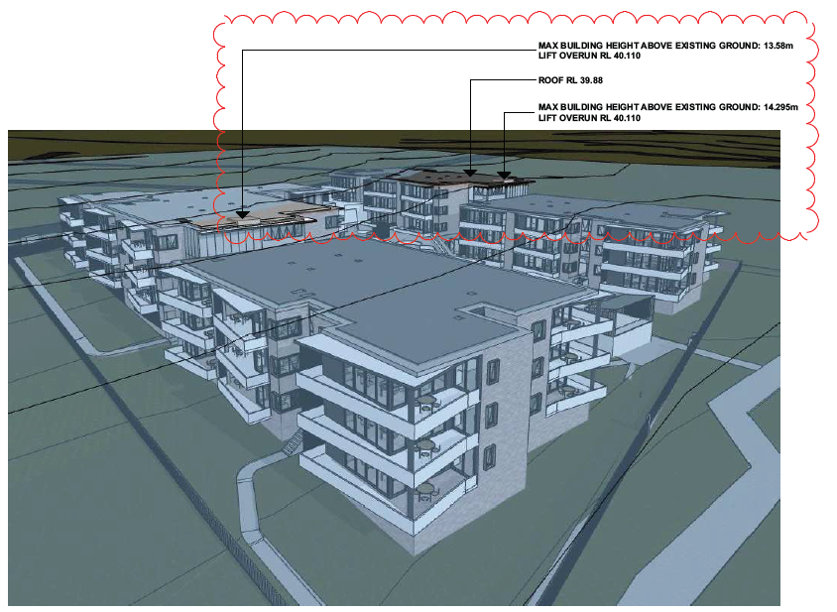

**Figure 3: 3D massing showing the areas of height exceedance**

Accordingly, a clause 4.6 written variation was submitted with the application outlining the development standard is considered unreasonable and the development displays sufficient environmental planning grounds to warrant contravention of the development standard. Specifically:

* The proposal is a high-quality built form that is responsive to the site’s topography and constraints.
* Building orientation and form, materials and finishes, and placement integrate the building with the site and will present a high quality/high amenity and cohesive outcome for the site and surrounds as required by the objectives of clause 4.3
* The development will largely present a three-storey outlook to the streetscape. When viewed from adjoining residential areas to the north, the new building will not present an overbearing bulk and scale as the views are largely filtered by the riparian vegetation
* The development is consistent with the objective of the height standard and the zone objectives even with the proposed variation
* The additional floor space distribution required for seniors housing necessitates larger dwellings when compared to a standard residential dwelling. Social benefits of providing high quality seniors housing in a sought-after location justifies the minor departure from the height control. Strict compliance with the height control will result in the removal of four dwellings designed specifically for seniors and people with disability.
* The non-compliant portion of the development is positioned centrally within the site without resulting in unreasonable loss of amenity to surroundings
* Strict compliance with the height control will require further excavation into the ground to accommodate the same number of dwellings which is considered to have more impacts than the minor height increase.

The clause 4.6 variation request submitted with the application adequately addresses the reasons for the contravention and identifies sufficient environmental planning grounds to justify that the compliance with the development standard is unreasonable and unnecessary, given no adverse impacts from the minor deviation.

Although the development contravenes the height standard, it is consistent with the objectives of clause 4.3 as the proposed built form with its three-storey outlook towards the Wilson Road is generally consistent with the desired character in Mount Hutton Town Centre Plan.

The applicant’s written request has adequately addressed the matters required to be demonstrated by clause 4.6. The development is in the public interest as it is consistent with the objectives of the particular standard and the objectives for development within the zone in which the development will be carried out.

The applicant’s clause 4.6 variation meets the tests described for such a variation and is therefore supported.

* 1. **Flooding**

The RE1 land on the site is affected by flooding from Scrubby Creek.

The application is accompanied by a flood assessment which confirms that apart from the shared path on RE1 land, the entire development is located outside the 1% AEP flood extent. The basement and lower level dwellings will have a floor level of 27.080m AHD which is approximately 1.28m above the PMF level.

External site works does not involve any filling on flood prone land, and areas of significant cut and fill are located outside the 1% AEP extent. Open style fencing is proposed along the RE1 land interface to limit impacts to the existing flood behaviour on the site and adjoining lands.

The assessment indicates potential for some inundation around the development during PMF events, however confirms the building will remain flood free and safe evacuation via Wilsons Road is possible in the event of any inundation (refer to Figure 4).

In assessing the proposal against the flood planning considerations under clause 5.21 of the *LMLEP*, the development is considered to ensure flood behaviour is not impacted by the development or the development does not pose any additional risk to life and property.

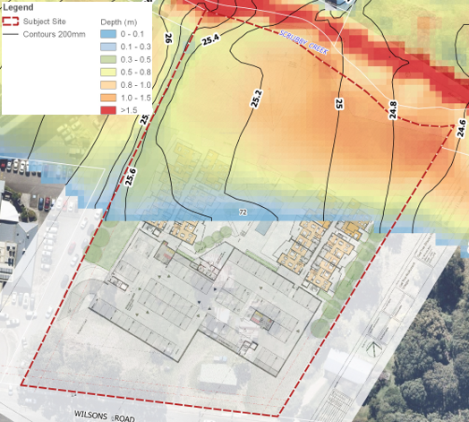

**Figure 4: PMF Flood depth and elevation**

**5.4 Stormwater management**

The proposed stormwater management plan includes strategies to manage the quantity and quality of post development flows.

All roof runoff will be captured in an 85kL rainwater tank below the western wing. A first flush device will be connected to the downpipes to remove leaf litter and sediment before entering the tank. The overflows from the rainwater tank will be directed to a 16kL onsite detention tank containing SPEL filters. Runoff captured by other drainage infrastructure located at the ground and podium levels will also be treated by these SPEL filters prior to their discharge into the creek. Pit inserts are provided to treat the runoff from hardstand areas. Due to the site levels, small areas of hardstand in the northern part of the site bypass the primary treatment measure in the onsite detention tank however they will still be treated by the grassed buffer before entering the creek.

MUSIC modelling undertaken for the proposal indicates the proposed treatment train effectively achieves the load reduction targets in the DCP. Similarly, results of the DRAINS modelling for various storm events up to 1% AEP indicate the post development flows to be comparable or lower than the pre-development flows with the proposed stormwater management system.

* 1. **Safety and security**

The site is within an area where there is evidence of reported crimes such as malicious damage, theft from vehicles and dwellings, motor vehicle theft, break and enter, robbery and assault. The design incorporates the principles of Crime Prevention Through Building Design (CPTED) to minimise opportunities for crime, as detailed below:

* the seniors housing development is provided with a separate entry and designed to function independent of the commercial uses to minimise trespassing opportunities
* the entry to the apartment buildings are provided internally for access control
* secure parking is provided for residents at the basement level
* the balconies, central recreational area, podium and terraces of the seniors housing development are orientated towards the reserve to maximise passive surveillance
* full height glazing is provided to the façade of commercial areas and communal rooms at the street level to maintain views over Wilsons Road
* fencing of appropriate type is used along the northern, western and eastern boundaries to clearly define the public and private domain
* side return fences are provided to prevent unauthorised entry to the seniors housing development
* landscape treatment comprising low ground cover and tall trees are provided at the site's frontage for territorial reinforcement without inhibiting natural surveillance
* small feature trees are proposed closer to the building to eliminate creating ‘natural ladders’ to the balconies and roofs
* the RE1 boundary interface is provided with palisade fencing and is clear of any landscaping to eliminate concealment opportunities
* lighting is proposed on either side of the gated entry from the RE1 land to assist with wayfinding and safety.

Additionally, the CPTED report by James Marshall includes a number of recommendations to enhance outcomes such as after hour security patrols, CCTVs, intercom systems with cameras at the entry points, directional signs, maintenance plan. These will be imposed through conditions.

The design and crime prevention strategy have been reviewed and supported by Council's Community Planner (CPTED), with additional conditions recommended to ensure appropriate lighting, secure locking systems and CCTV installation and coverage .

* 1. **Acoustic impacts**

The acoustic assessment by Spectrum Acoustics investigates the noise impacts from the development on the surrounding uses. Impact of noise from the adjoining tavern and traffic has also been considered in the assessment.

Project noise trigger levels were determined using the background noise levels from a previously undertaken noise monitoring study for works associated with the adjoining tavern. Additional noise monitoring was undertaken by Spectrum Acoustics on 14 January 2022 at three different locations along the western boundary to determine the existing acoustic environment at the interface to the tavern. The noise logging was undertaken between 8.30pm and 11.30pm when a performance to amplified accompaniment was occurring at the tavern.

The results of the noise monitoring were assessed against the most stringent Lmax noise ( L1) sleep disturbance criterion. The noise levels from the tavern were generally lower than the sleep disturbance screening criterion. However exceedances were noted in the south-western part which aligned with the tavern entry, and the assessment also identified the potential for annoyance from low frequency entertainment noise. The noise exceedance was mainly from the raised speech of patrons waiting at the front of the tavern for transport and this could be attenuated by a standard façade treatment (with windows open).

As low frequency (bass) components of the entertainment noise can be a source of annoyance, all bedroom windows with line of sight to the tavern will be required to have 6.38mm laminated glass to lower internal noise ingress into the rooms (windows closed) by about 5dB(A). Conditions to this effect will be imposed.

With respect to traffic noise, the report confirmed dwellings closest to Wilsons Road are capable of achieving the project internal noise goals through standard façade construction. Similarly, suitable noise attenuation of noise from the car park and driveway on the western side can be achieved without any specific acoustic treatment.

The report also found the development will not have adverse traffic noise impacts to surrounding users given the limited traffic movement associated with the development.

Impact of air conditioner and other plant noise from the development on the closest sensitive receiver at 74 Wilsons Road was also considered. The report found the development can achieve acoustic standards and no further treatments or attenuation is required. A condition will be imposed to require the location and type of air conditioning and other plant to be certified by an acoustic consultant prior to the operation of the premises.

In summary, the development will not have adverse noise impacts that affect the amenity of the residents or adjoining uses.

* 1. **Social Impacts**

Due to the site’s proximity to Lake Macquarie Tavern, consideration has been given to anti-social behaviour, lighting spill, visual and acoustic privacy, to ensure the development can achieve amenity for the future residents. To address this matter, a Social Impact Assessment has been submitted .

The report identified the late-night operations at the tavern are cognisant of the impacts on the residential amenity. With a view to reduce noise impacts, any live music performance at the tavern is limited to 11.00 pm. As a further measure, the courtesy bus for the tavern operates on the western side of the building to reduce noise from patrons leaving the premises. These practices are expected to continue into the future to minimise impacts on nearby residential developments.

The design incorporates several elements to minimise the interaction between the tavern and the seniors housing development including the following:

* the western boundary is provided with 2.1m high solid metal fencing at the interface between the dwellings and the tavern to eliminate direct views, stray lighting impacts and opportunities for littering.

This fencing transitions to solid masonry construction along the driveway ramp for structural support, and no fencing is proposed forward of the building line for casual surveillance.

* the development maintains a minimum setback of 7.4m to the western / common boundary.
* existing street lights and lighting at the tavern are directed away from the development.
* the landscape plan includes tall canopy trees and a line of shrub plantings along the western boundary fence line provide visual privacy and amenity to the apartments.

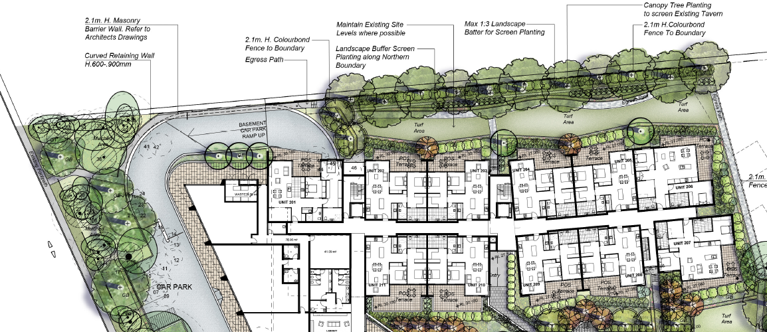

**Figure 5: Western boundary landscaping and fencing outcomes**

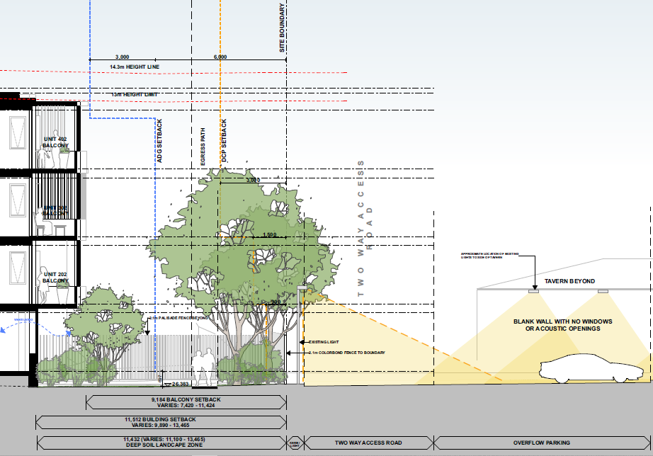

**Figure 6: Western boundary interface section**

The specialist reports submitted with the application do not identify any adverse impacts that affect the amenity and well-being of future residents. In addition to the CPTED considerations in the design, additional safety will be ensured through CCTV at all access points to the facility and after-hours security patrols to monitor the boundaries, grounds and access points, and other recommendations in the CPTED report. Assessment by Spectrum Acoustics confirms general compliance with the noise criteria and treatment to the windows of specific dwellings to eliminate any discomfort from low frequency entertainment noise. Impacts during construction will be managed through a construction management plan.

The development will provide housing for seniors in close proximity to a number of services (retail, health, recreational and community).The layout incorporates adequate communal spaces to foster relationships between residents, reducing the likelihood of isolation, and creating a sense of community. The local economy will benefit from additional clientele and increased spending. The development will contribute positively to the locality without any unreasonable level of impact.

* 1. **Interface outcomes**

The development achieves good interface outcomes through landscape transitions and appropriate fencing at the threshold between the public and private domain.

On the eastern side, there is a minimum separation of 6.7m to the boundary. Fencing comprises 2.1m solid metal fencing with palisade fence towards the frontage. Screen plantings and small feature trees are provided near the eastern façade for visual separation to the neighbouring dwelling. The balconies and living areas of the dwellings on the eastern side are orientated to provide casual surveillance over this space. A number of existing trees within the eastern setback will be retained, refer to Figure 6.

As discussed previously, the western side of the development achieves a minimum separation of 7.4m to the boundary. 2.1m high solid metal fencing is proposed at the interface to the tavern with a section of masonry wall along the access driveway. Canopy trees and tall shrubs are proposed along the fence line for visual buffer. Additional shrub plantings and feature trees are proposed closer to the western façade to soften the subfloor element as illustrated in Figure 5.

The proposed building setback near the zone boundary varies significantly. The eastern wing and central courtyard elements (deck and pergola) are set back in excess of 5m from the RE1 boundary while the western wing has a minimum setback of 2.4m. Palisade fencing (2.1m high) with brick piers is proposed at the interface with the reserve for permeability. A single point of entry will be provided from the reserve with footpath connection to the proposed shared path.

The pool deck overlooking the reserve and the seating below creates opportunities for casual interaction between the residents and the reserve. The courtyard style configuration maximises views over the reserve by appropriate orientation of balconies and living areas. Plantings at this interface comprise tall shrub plantings to soften the subfloor elements and tall canopy trees for visual relief. Apart from accent shrubs near the entry, all plantings are proposed closer to the building to maintain clear views over the fence line. Figure 7 illustrates the interface outcomes at the reserve.

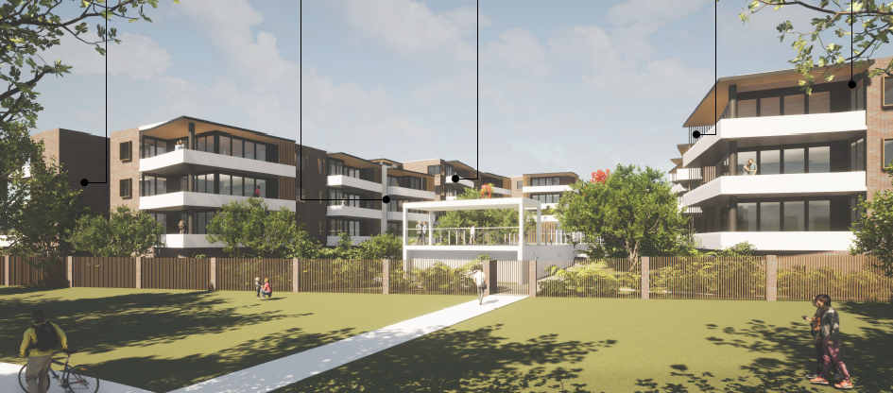

**Figure 7: View of the development from the reserve**

At the site’s frontage, the threshold to Wilsons Road is provided with native trees and garden beds to delineate the public and private domain, as shown in Figure 8. This is consistent with Mount Hutton Town Centre Plan which requires large canopy trees within the front setback to provide a tree lined corridor along Wilsons Road. No street trees are proposed due the narrow verge width of the road reserve.

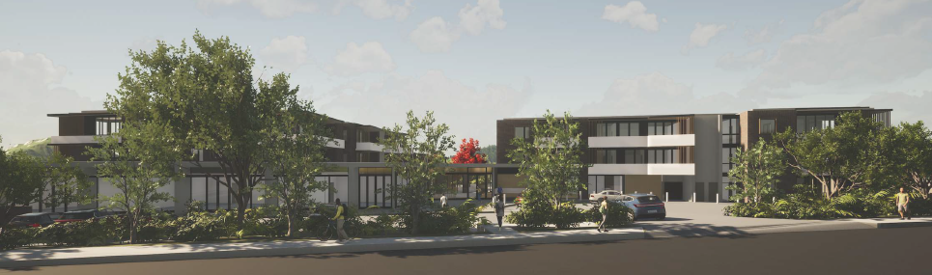

**Figure 8: View of the development from the reserve**

* 1. **Traffic and transport**

The site is accessed off Wilsons Road, a local road with a single lane of travel in each direction and a speed limit of 60km/hr. The application is accompanied by a Traffic Impact Assessment (TIA) prepared by Seca Solutions to identify impacts of the development on the local road network.

The development is estimated to generate 29 trips per day in the evening peak, and 151 trips per day. A low traffic generation rate of five trips in the morning and afternoon peak hours is assumed for the commercial tenancies as they would largely cater for on-site residents. The additional traffic is not significant and will not have an unacceptable level of impact on the local road network.

Existing driveways will be replaced by a single 9m wide driveway. The TIA confirms the sight distances available at the entry exceeds the requirements of AS2890 and Austroads.

Wilsons Road has an existing sheltered right turn lane for access to the shopping centre. Adjustments are proposed to this lane to facilitate right turn movement into the site, as indicated in the Figure xx. The design has been reviewed by Council’s Traffic Engineer and deemed satisfactory.

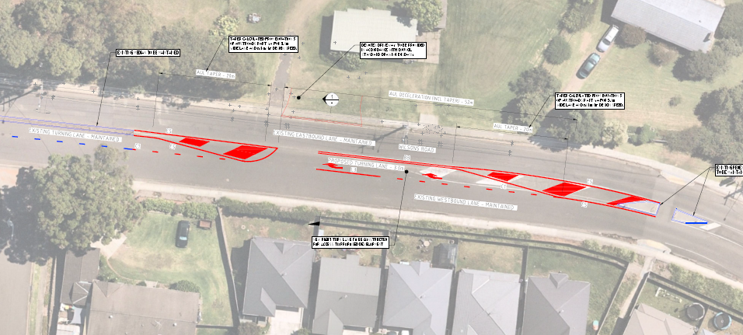

**Figure 7: Proposed changes to the right turn lane on Wilsons Road**

The parking provisions for the development comprise:

* Ten at grade parking spaces (including two disabled parking spaces) at the frontage.

Eight of these spaces are for the commercial uses and two are designated as visitors parking for the seniors housing development.

* 83 parking spaces including six disabled parking spaces at the basement level

The parking provision for the commercial uses comply with RMS’ rate of 1 space per 40m2 GFA.

Parking for seniors housing has been assessed in accordance with the standards in SEPP Housing 2021 which requires 0.5 space for each bedroom. This equates to 72 car parking spaces for the seniors housing development. The parking at the basement level exceeds this requirement. The access audit confirms the car parking spaces are of suitable dimensions and complies with accessibility requirements in AS 2890.6

Deliveries to the commercial tenancies are typically in small vans which can utilise the parking spaces in front of the building. A service bay is proposed to the east of entry to accommodate a medium rigid truck for larger deliveries. Service vehicles are capable of entering and exiting in a forward direction.

A construction traffic management plan will be required to manage traffic during construction phase

The development will increase the pedestrian movement between the site and the shopping centre. The footpath at the frontage will be require upgrade as per Council’s standards. A new shared pathway to the rear of the site will also facilitate additional access to the shopping centre.

1. **CONCLUSION AND RECOMMENDATION**

This development application has been considered in accordance with the requirements of the EP&A Act and the Regulations as outlined in this report.

The proposal aligns with the strategic intent in Mount Hutton Town Centre Plan and will provide additional housing stock for the ageing population in a well serviced area. The site is capable of accommodating the development with an acceptable level of impact.

Following a thorough assessment of the relevant planning controls, and the key issues identified in this report, it is considered the application can be supported.

It is recommended Development Application DA/2899/2021 for seniors housing and commercial premises at 72 Wilsons Road be approved subject to the draft conditions of consent attached to this report at Attachment A.